Geometry: Unit 5, Lesson 10
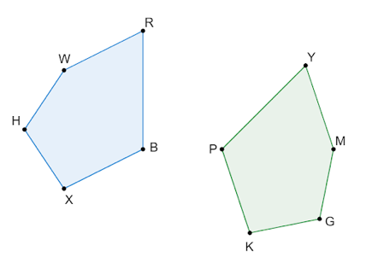
- Polygons $RBXHW$ and $YPKGM$ are shown, where $YM=5x$, $RB=7x-3$, $HW=36$, $PK=YM$, and $HX=HW$. Polygon $RBXHW$ is congruent to polygon $YPKGM$. The perimeter of polygon $YPKGM$ is $222$ units. What equation can be used to determine the value of $x$?

$$7x-3+2\left(5x\right)+2\left(36\right)=222$$

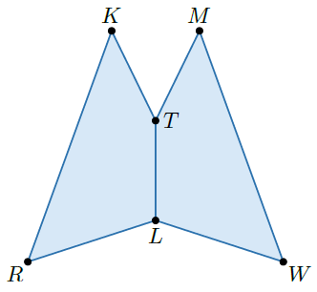
- Anna is making a pattern for a dog outfit. One part of the pattern is shown, where $KTLR≅MTLW$ and $m∠TLR=108°$, $m∠WMT=46°$, and $m∠MWL=52°$. What is the measure of $∠LTK$?

$$154°$$
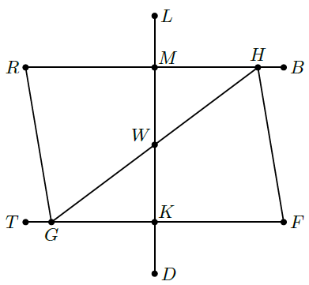
- A landscaping engineer used computer software to draw a garden she is designing. Her drawing is shown. Line segments $DL$, $RB$, $TF$, $GR$, $FH$, and $GH$ represent paths around and through the garden. Quadrilaterals $MWGR$ and $KWHF$ are congruent, and triangles $HMW$ and $GKW$ are congruent where $WG=35$ meters (m), $RG=51.3m$, $WM=38m$ and $RM=40m$. What is the total distance someone will walk if they enter at point $K$ and walk along the paths made by the quadrilateral $KWHF$?

$164.3$ meters

